**Practice Questions**

**Vectors**

1. A displacement vector in the *xy* plane is 4.3 m long and directed at angle of 40° in Fig-1. Determine (a) the *x* component and (b) the *y* component of the vector.

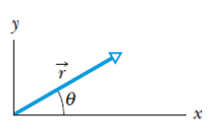 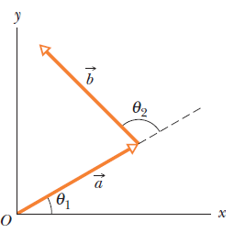

Fig-1 Fig-2

1. The two vectors ***a*** and ***b*** in Fig-2 have equal magnitudes of 10m and the angles are θ1= 35 $⁰$ and θ1= 102 $⁰.$ Find the (a) x and y components of their vector sum ***r*** (b) the magnitude of ***r*** and (c) the angle ***r*** makes with the positive direction of the x axis
2. Find the area of the parallelogram determined by the vectors: 2i - 13j + 5k and 5i + 2j - 4 k. What is the area of triangle determined by 2 vectors A=3i+4j-k and B=-3i+7j-4k ?
3. The *x* component of vector ***A*** is 25.0 m and the *y* component is 40.0 m. (a) What is the magnitude of ***A*** (b) What is the angle between the direction of and the positive direction of *x*?
4. Find the angle between the vector A= 2i -3j+5k and the x, y,and z axes, respectively.
5. Calculate the angle between “r” and the positive z-axis. (c) Find the angle between “a” and “b”. where a = 5i +4j -6k , b= -2i +2j+3k and c = 4i+3j+2k , r = a+b+c.
6. Determine the value of “X” such that **A** = 4**i** + X**j** + 2**k** and **B** = 4**i** - 8j - 2**k** are perpendicular.
7. Vector***a*** has magnitude 5.0 m and is directed east. Vector ***b*** has magnitude 4.0 m and is directed 35◦ west of north (Fig-3). What are

**(i)** the magnitude and

**(ii)** the direction of **a + b**?

What are

**(iii)** the magnitude and

**(iv)** the direction of **b − a**?

Draw a vector diagram for each combination.

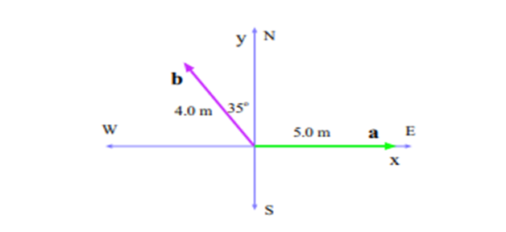Fig-3

1. In the sum A + B = C, vector A has a magnitude of 12.0 m and is angled 40.0 ◦ counterclockwise from the +x direction, and vector C has magnitude of 15.0 m and is angled 20.0 ◦ counterclockwise from the −x direction. What are (a) the magnitude and (b) the angle (relative to +x) of B?
2. Find the angle between A = −5i – 3j + 2k and B = −2j – 2k
3. Prove that two vectors must have equal magnitudes if their sum is perpendicular to their difference.
4. Someone claims to have found a vector A such that



Do you believe this claim? Explain by doing calculations.

1. Two vectors are given by A = −3i + 4j and B = 2i + 3j. Find (a) A × B and (b) the angle between A and B.
2. Vectors A and B lie in an xy– plane. A has a magnitude 8.00 and angle 1300: B has components Bx= -7.72 and By=-9.20 (a) What is 5A . B? What is 4A x 3B in unit vector notations. (b) What is the angle between the direction of vector A and vector (4A x 3B)? (c) What is A +3.00 k in unit vector notation and its magnitude?
3. In Fig-4 , a vector with a magnitude of 17.0 m is directed at angle 56.0° counterclockwise from the +x axis. What are the components (a) ax and (b) ay of the vector? A second coordinate system is inclined by angle 18.0° with respect to the first. What are the components (c) ax and (d) ay in this primed coordinate system?

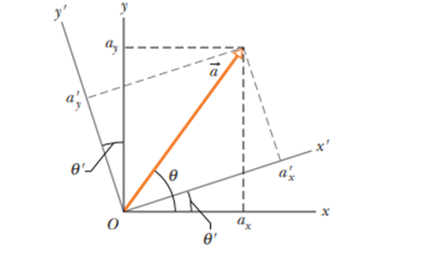Fig-4

1. (a) In unit-vector notation, what is the sum a + b if a = (4.0 m)i + (3.0 m)j and b = ( -13.0 m)i + (7.0 m)j ? What are the (b) magnitude and (c) direction of a + b?
2. A car is driven east for a distance of 50 km, then north for 30 km, and then in a direction 30° east of north for 25 km. Sketch the vector diagram and determine (a) the magnitude and (b) the angle of the car’s total displacement from its starting point
3. The three vectors in Fig-5 have magnitudes a = 3.00 m, b = 4.00 m, and c = 10.0 m and angle θ = 30.0°. What are (a) the x component and (b) the y component of a ;(c)the x component and (d) the y component of b; and (e) the x component and (f) the y component of c? If c = pa + qb,what are the values of (g) p and (h) q?

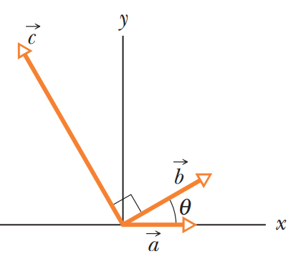

Fig-5